Message from Sean Peay, Dynanet CEO
Dynanet’s Mission is to provide system integration services focused on our public and private customer’s mission that solves complex business problems.

Dynanet Corporate goals
Provide a dynamic and challenging environment as the employer of choice.

Ensure customer satisfaction through the delivery of quality people, services, and products.

Anticipate customer’s needs through the use of innovative and cutting edge approaches and solutions.

Be a socially responsible company.

Be a trusted business partner.

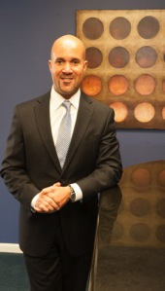
Dynanet is a trusted source for our customers and we continue to receive kudos and thanks for the work we do. Great customer service is part of our company culture and DNA. We live it every day and it is making a difference. Our customers appreciate the extra efforts we put into every project and every deliverable. If your customer recoginizes you for a job well done, let us know. We want to share these positive results with our customers – existing and potential. Our joint successes make Dynanet the great company that it is. Congratulations to each of you for a job well done!

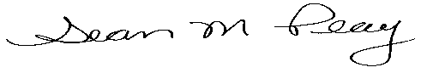

Corporate News

Dynanet Wins BPA to Support OPM
April 2016
Dynanet received an award for the ECMS eCase configuration project. This is a five-year BPA for the configuration of the eCase product for OPM, along with additional project tasks.

Dynanet Wins DOI Telecommunications Contract
April 2016
Dynanet was awarded the re-compete of its Telecommunications Contract with the Department of Interior (DOI). As the prime contractor, Dynanet provides technical, administrative and operational support for DOI’s telecommunications department. Additionally, Dynanet provides operations and maintenance of DOI’s Alcatel –Lucent OmniPCX Enterprise (OXE) Telephony system and the AVST CX-E Voice Mail Systems. Implemented in the mid 2000s, these systems have become critical to the Department’s ability to perform its mission of protecting and managing the Nation’s natural resources and cultural heritage. This system manages over 10,000 telephone extensions and voicemail boxes, tying together DOI organizations and facilities located throughout the Nation including Colorado, New Mexico and multiple facilities within the Washington DC metro area. Congratulations to Dynanet’s DOI team!

Follow Dynanet on LinkedIn
Dynanet is on LinkedIn. Please follow Dynanet on LinkedIn. Search for “Dynanet Corporation”.

Dynanet Now on the Eagle II Contract Vehicle
April 2016
Government customers can now access Dynanet through the Eagle II Contract (HSHQDC-13-D-E2030). The Eagle II Contract is a multiple-award indefinite delivery/indefinite quantity (IDIQ) contract vehicle, specifically designed as the preferred source of information technology (IT) services for the majority of the Department of Homeland Security’s (DHS’s) enterprise infrastructure and initiatives. EAGLE II IT service solutions include three functional categories (FC's):

FC1 – Service Delivery, including Integration, Software Design/Development, Operations & Maintenance;
FC2 – Information Technology Program Support Services; and
FC3 – Independent Verification and Validation

Dynanet Participates in another GSA IT Contractor Collaboration Event (C2e)
April 2016
The topic of this month’s event was "How Do You DevOps?" The group examined the goals and objectives of the practice, the differences and similarities between Agile and DevOps, and finally the steps necessary to accomplish both continuous delivery/integration and continuous deployment. The discussion led to common constraints to any DevOps practice, including Culture, Policy, Process, Technology and Contractual. The group’s goal is to return to this topical question at subsequent events.

Social Media
Dynanet’s social media presence continues to go strong. We can be found on Facebook, LinkedIn, and our web site. If you are not following Dynanet on LinkedIn, please go to linkedin.com and search for Dynanet Corporation.

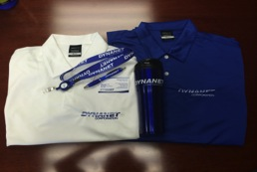
Dynanet Apparel
Have you ordered your Dynanet company shirt? Have you received your Dynanet lanyard and business cards? If you are interested in finding out more about these items, please contact Sue Pauls at 443.661.1403.

Employee News

Welcome New Employees
Office of Personnel Management (OPM)

Matt Cowen, Senior Quality Assurance Analyst

Employee Anniversaries

Dynanet Headquarters
Congratulations to Sue Pauls, Recruiting Coordinator, for her one year of service.

Employee Kudos

Lockheed Martin Recognizes Anusha Bheemidi
April 2016


Anusha Bheemidi was recognized for her work on the GSA CAMEO contract. Ron Rabinowitz, Lockheed Martin, IS&GS, had the following to say about Anusha’s performance. “Anusha has been a tremendous asset to my CDM team since the time she joined the CAMEO Program almost one year ago. The CDM project is developing and deploying a new system for our GSA customer, under extremely tight deadlines. As our Business Analyst, she has produced the highest quality work for the project. But more significant than that, she is a team player who has performed well above and beyond expectations. When our CDM tester was on extended leave and we were in dire need of test support, she willingly stepped in to help the team, in addition to covering all of her BA responsibilities. It was also during this same period that [we] required surge support for [the] VSC project, which she willingly provided. She has a positive attitude of teamwork and collaboration, she is well respected by her coworkers, and continues to be a tremendous asset to the CAMEO Program.” Congratulations Anusha!

Employee Profile

Diane Shell, Accounting/Director of Human Resources
I have been a part of the Dynanet team for almost 15 years. I started off in the accounting department. The accounting department was very small, just myself and Bill Gillan. I began to take on different responsibilities as needed for the growing business. Through the years this has lead me into other areas, such as contracts, IT support, payroll, Human Resources, and even most recently being part of Dynanet’s CMMI appraisal team.
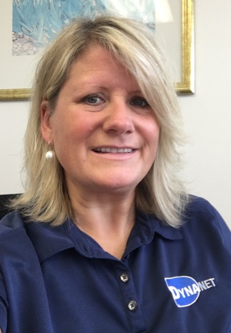
About Dynanet
Dynanet Corporation has a long history of successfully assisting federal and state governments in accomplishment of their missions. The proof of our success is in the numerous accommodations and awards we have been given and the list of partners who choose Dynanet as
a business team member. A highly experienced and senior leadership team with both private sector and federal experience leads our talented and certified professionals.

8182 Lark Brown Road, Suite 300 | Elkridge, Maryland
21075 | 443-661-1403 | www.dynanetcorp.com

Feedback

We hope you find the information in this issue of the Dynanet Newsletter useful. Please let us know what you think. Send your feedback to Sherri Brown at sbrown@dynanetcorp.com
I grew up in Severn, MD and received my B.A. degree from Salisbury University in 1992. I had several jobs after college, (several with my mentor, Bill Gillan) before finding my home at Dynanet.

When I’m not at the office I enjoying spending time with my husband of 22 years and my three kids, 15, 14 and 14, yes I have twins! I spend a lot of time chauffeuring kids to their extra-curricular activities. I love to travel, most recently to St. Thomas in the Virgin Islands. I also love to garden and bake. During the football season you will find me either at the game or hosting a party at my house to watch the game. We are huge Baltimore Ravens fans!

Dynanet is my home away from home and the people I work with every day are like family to me. I enjoy coming to work and doing whatever I can to make Dynanet a success!

2015 Events

Cool Schools Polar Bear Plunge
March 2016

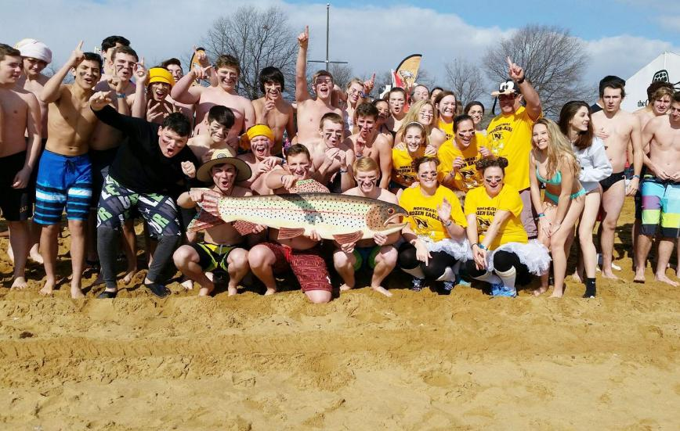
Dynanet made a donation to the Cool Schools Polar Bear Plunge to benefit Special Olympics Maryland. Diane Shell’s daughter attends Northeast High School and participated in this event. The School raised a total of $8,659.00, ranking them 8th out of 70 teams that participated. The 70 schools combined raised $267,474.
Northeast High School Polar Bear Plunge Participants

